!!!SAFETY ALERT!!!
TRIPOD TANKS
To all fuel users,
This is an important safety alert from the Fuel Distributors Industry Safety Committee and Worksafe NZ.
There has recently been an incident on a farm/site where a “Tripod” overhead tank collapsed while being filled by a Fuel Tanker driver, who was subsequently seriously injured. The root cause was significant corrosion (rust) on one of the tank legs- see examples below. There were also farm implements in proximity to the tank which contributed further to the driver’s injuries when they fell on them.
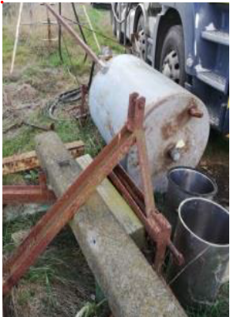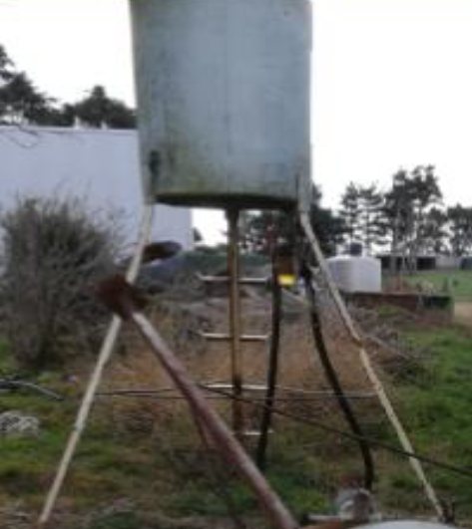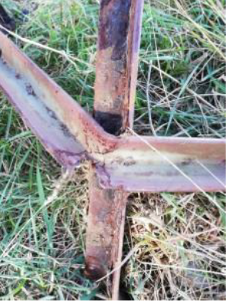
We want to work with you to keep you, your employees and Fuel delivery drivers safe and to make sure an accident like this does not happen on your farm/site.
As a matter of priority, please can you act to:
1. Check each of your fuel tanks and support structures for signs of corrosion (rust) or metal fatigue
2. Make sure all tanks are properly secured to a flat foundation
3. Ensure the work area around each tank is safe, with a clear path free of obstacles
4. If you have any concerns or would like assistance please contact your local Fuel supplier
For further information please visit the WorkSafe guidelines for above-ground fuel storage on farms.
Thank you in advance for doing this. Your local fuel supplier team are here to help and we can work with you to ensure a safer operational environment for all.

Kind regards,
FDISC members.

